Political Risk Assessment
Pacific Gas & Electric: The Future of the Energy System in California

Prepared by the Leadership & Democracy Lab, University of Western Ontario
Published August 2022
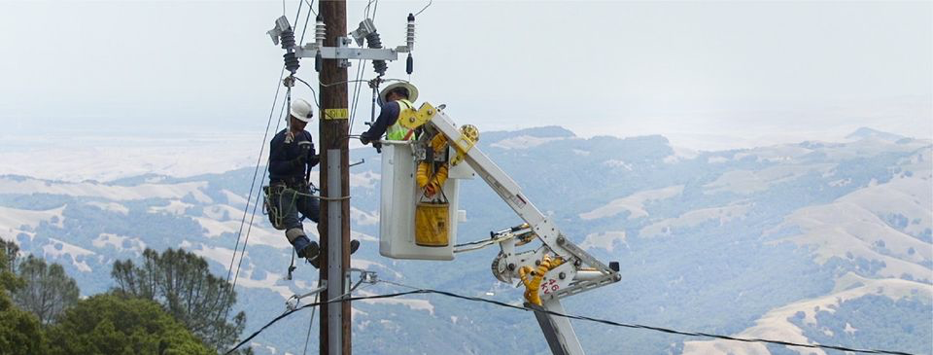

Generated By  Alden Eakins – Student Director  Jordan Tepper – Team Leader  Sarah Kabani – Research Analyst  Jehan Mohammed – Research Analyst  Katie Campbell – Research Analyst  Andrei Chen – Research Analyst  Noha Shaalan – Research Analyst  Democracy Lab Faculty Director  Dr. Cristine de Clercy  Martin Eidenberg  Dr. Peter Ferguson  Graphic Design & Report Layout  Calvin Dong  Alec Mazurek | Leadership and Democracy Lab  University of Western Ontario  1151 Richmond Street  London, Ontario, Canada, N6A 3K7  http://www.democracylab.uwo.ca/  Published August 2022. All rights reserved.

Table of Contents

Introduction 4
Corporate Risk 5
Social Risk 7
Policy Risk 11
Figures 14
Citations 15

Introduction

The histories of California and the Pacific Gas and Electric Company (PG&E) are inextricably linked. Tracing its corporate ancestry back to the California Gold Rush, the utility company was officially incorporated in 1905. Today, after several decades of remarkable growth, PG&E is recognized as the largest natural gas and electric energy company in the state and is among the five largest utilities across the United States. PG&E services approximately 16 million people throughout a 70,000-square-mile service area in northern and central California and maintains 108,681 circuit miles of electric distribution lines and 18,466 circuit miles of interconnected transmission lines.
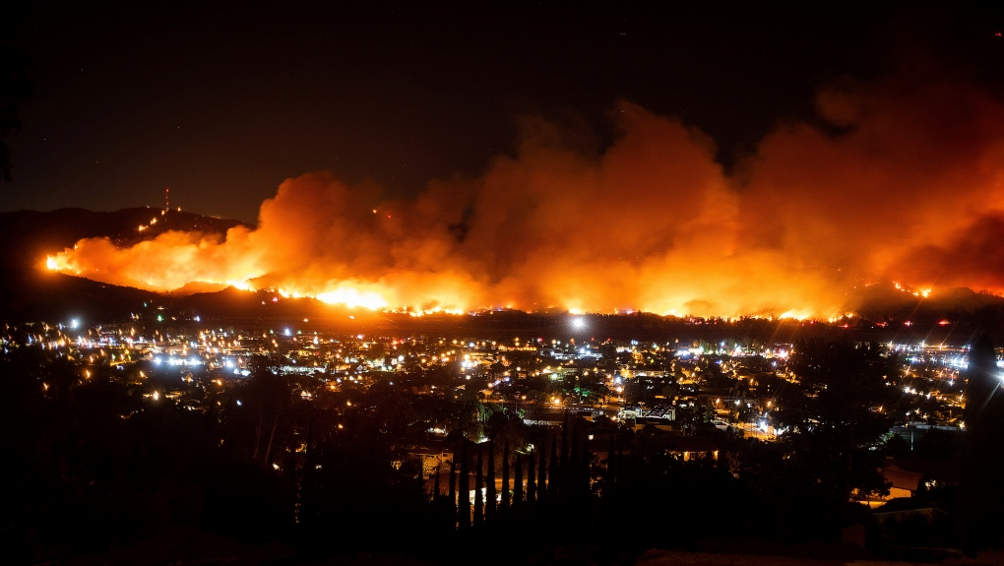
In recent years, PG&E has been responsible for wildfires that have destroyed hundreds of thousands of acres. Five of the ten most destructive fires in California since 2015 have been linked to PG&E’s equipment. In 2019, the company pleaded guilty to 84 counts of manslaughter and has previously admitted that its electric grids were responsible for a fire. PG&E also faces civil and criminal actions from other wildfires. After PG&E amassed $30 billion in liability from the wildfires caused by its equipment, the utility sought bankruptcy protection in January 2019. The company exited bankruptcy in July 2020, promising to work to prevent further wildfires. Victims of the fires have continued to seek compensation for their losses that became part of the company’s bankruptcy plan.
Providing consistent power for 16 million people, maintaining the integrity of more than 100,000 miles of power lines and answering to California’s regulators and company shareholders is an important and necessary job. Accordingly, it is imperative that PG&E repairs its relationship with the state of California – not only for the future of the company but for the well-being of the communities in which the utility operates as well. To do so, risks must be effectively mitigated through nimble, timely responses paired with significant investment in infrastructure, technology, and critical support systems.
Energy storage is an important strategy for PG&E, as it would enable the organization to save electricity for future use, when and where it is most needed. Energy storage creates efficiencies which allow for enhanced capabilities to improve overall electric grid value, including reducing greenhouse gases and providing mitigation strategies to climate change factors.
Figure 1: Maria Fire above Santa Paula, California (AP Photo/Noah Berger)

Corporate Risk

Background
In the past decade, PG&E’s aging electricity distribution infrastructure was found to be responsible for causing over 20 major incidents of wildfire. As a result, PG&E filed for Chapter 11 bankruptcy on January 29, 2019. During its bankruptcy period, PG&E reached a court-approved settlement with wildfire victims for $13.5 billion. It is important to note that this settlement only covers PG&E’s liability arising from wildfires that occurred prior to and including the 2018 Camp Fire. Unfortunately, PG&E continues to be plagued by wildfire liability issues after the settlement. The continued presence of significant financial liability issues has also hampered the company’s creditworthiness and market valuation of its securities.

Credit Risks
Investors have not been the only ones that fear the risk of default and increased liabilities on PG&E, as their credit ratings indicate a caution to lenders. The evidence for this: Fitch Ratings gave “PG&E Corporation's and Pacific Gas and Electric Company's Issuer Default Ratings at 'BB'/Stable.” The above insinuates there may be “elevated vulnerability to default risk, particularly in the event of adverse changes in business or economic conditions over time.” Default risk, alongside the fact that there was an increase in PG&E’s credit facility from $2.2 billion in Q3 of 2020 to $2.9 billion in Q3 2021, may impact of financial commitments on PG&E are growing substantially.

Financial Risk (Liability Arising from post-Camp Wildfires)
The Doctrine of Inverse Condemnation “entitles property owners to compensation if their property is damaged by a public use.” In 1885, the California Supreme Court held that inverse condemnation applies even in situations where only tangential harm is done to private properties. In Barham v. Southern California Edison Company (1999) 74 Cal. App 4th 744, the California Supreme Court specifically determined that investor-owned utility companies, like PG&E, are liable for damages caused from wildfires under inverse condemnation. The application of this doctrine worsens PG&E’s liability position in three distinct ways. First, under inverse condemnation, PG&E is held to a strict liability standard – as long as a fire is caused by PG&E’s equipment, it is liable for damages even if it did not behave negligently. Second, according to the California Code of Civil Procedure, “in inverse condemnation lawsuits, PG&E must pay the plaintiff’s attorney’s fees” – thus incentivizing victims to litigate. Lastly, inverse condemnation also enlarges the scope of PG&E’s liability, as it provides a remedy for mere “tangential harm” to properties, as noted above.
The 2019 Kincade Fire burned over 77,000 acres, destroyed nearly 400 structures, and led to one of the largest evacuations in the region’s history. Moreover, the malfunctioning of a PG&E transmission tower was responsible for causing the fire. Liability lawsuits against PG&E were subsequently filed by local governments, residents, and businesses. The company ultimately settled with local governments for $125 million. However, class-action applications initiated by affected residents and businesses under inverse condemnation are still ongoing. PG&E is estimated to be liable for at least $600 million in damages.
The 2020 Zogg Fire burned over 56,000 acres, destroyed over 200 structures, and caused 4 deaths. The fire was sparked by a falling pine tree contacting PG&E’s electrical lines. The Shasta County District Attorney has laid 31 criminal charges, including 4 counts of manslaughter, against PG&E. In addition to these criminal charges, the company admits on its Form 10-K filing with the SEC that it will likely be found civilly liable for property damages caused by the fire.
The 2021 Dixie Fire was the second-largest wildfire in California’s history. It burned over 960,000 acres and destroyed upwards of 1,300 structures. Cal Fire investigators announced on January 4th, 2022 that the fire was, once again, caused by PG&E’s equipment. It is estimated that PG&E will be liable for at least $1.15 billion in damages. The company’s most recent 10-Q SEC filing suggests that they expect the California Wildfire Fund and its own private insurance to cover most of the liabilities related to the Dixie Fire.
The California Wildfire Fund is a liability fund established by the California State Assembly in 2019 with $21 billion to “help utilities cover the liability costs of major wildfires started by their equipment.” However, according to Assembly Bill 1054, the enabling legislation of the fund, access to the fund is contingent on maintaining a valid safety certification pursuant to the California Public Utilities Code. At the time of writing, the California Public Utilities Commission (CPUC) has initiated proceedings to revoke PG&E’s safety certification. Therefore, it is unclear whether PG&E will be able to access the fund to resolve all the instances of liabilities.
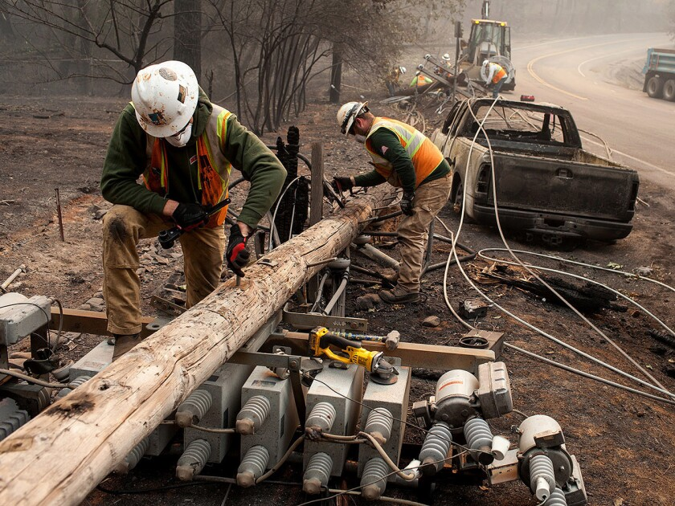
Figure 2: PG&E workers disassembling power lines after the Camp fire
Mitigations
Prioritizing Safety Certification and Standards
Maintaining its safety certification should be PG&E’s utmost priority because it determines their ability to access the California Wildfire Fund (Fund). A recent report published by Fitch Ratings emphasized the important role that continued access to the Fund has in preventing the further downgrading of PG&E’s credit rating. The Fund provides a necessary liquidity cushion for potential liabilities arising from future large-scale wildfires caused by PG&E’s equipment. As the company admits, its wildfire mitigation effort will be a decade-long endeavor, and it is reasonably certain that PG&E’s equipment will cause new wildfires in the interim. PG&E depends on the liquidity cushion provided by the Fund to prevent insolvency in the event of being found liable for wildfires as devastating as the 2018 Camp Fire. Therefore, failure to maintain its safety certification will severely undermine PG&E’s ability to securely provide necessary long-term financing for the energy storage project.
Fulfilling CPUC’s “prudent manager standard” will allow PG&E to recover the costs incurred from wildfire liabilities by increasing customer electricity rates. The California Supreme Court’s rationale for making investor-owned utilities (like PG&E) subject to inverse condemnation in Barham is predicated on the notion that they can effectively pass costs onto the public through utility price -increases. Indeed, section 454 of the California Public Utilities Code permits utilities “to recover its costs (including wildfire liabilities),” as long as they are considered to be “just and reasonable.” In determining San Diego Gas & Electric’s 2007 request to increase electricity rates to recover its wildfire-related liability expenses, the CPUC held that liability costs are deemed “just and reasonable” if the utility has met the “prudent manager standard.” The CPUC defines the standard as, “following the exercise of reasonable judgment in light of the facts known or which should have been known.” Though the standard is vaguely defined and, therefore, subject to the case-specific interpretation of the CPUC, it provides a medium-term solution for PG&E’s liability-related financial risks. Therefore, PG&E should re-design its ongoing mitigation strategy to fulfill the “prudent manager standard” as soon as reality permits.

Utilizing Energy Storage Technologies Further approaches may constitute gaining increased shareholder trust by storing energy in a more reliable manner, which reduce the risk of wildfires. This is apparent as the CEO has stated that: “PG&E’s new remote microgrid replaces traditional electric poles and wires - reducing wildfire risk for PG&E customers in a high fire-threat area.” Therefore, PG&E should orient its infrastructure investment strategies to focus on the ongoing energy storage project, as it provides a multitude of benefits — particularly in mitigating the company’s current financial, credit, and market risks.

Social Risk
Background
PG&E is increasingly facing a newer form of risk: social risk. Social risks arise from negative perceptions of an organization’s impact on the community and have significant reputational and financial repercussions. In recent years, California’s largest utility has been responsible for wildfires that have destroyed hundreds of thousands of acres. Five of the ten most destructive fires in California since 2015 have been linked to PG&E equipment. This has adverse implications on racialized communities as climate crises – particularly wildfires – have been proven to exacerbate vulnerabilities within communities of colour.
Further, in 2021, PG&E announced a plan to bury 10,000 miles of power lines in response to the wildfires. However, widespread concerns have been raised indicating that the plan fails to adequately address the fire-danger risks and is instead a for-profit venture. Moreover, the greater financial cost required from users, in a time where the socio-economic well-being of many have been negatively compromised due to the COVID-19 pandemic, has generated additional ill-disposed views towards the plan and has further contributed to the company’s high-unfavourability rating in California and surrounding regions.
Providing consistent power for 16 million people, maintaining the integrity of more than 100,000 miles of power lines, and answering to California’s regulators and company shareholders is an important and necessary job. Accordingly, it is imperative that PG&E repairs its relationship with the state of California – not only for the future of the company but for the well-being of the communities in which the utility company operates as well.

Risks
Public Perceptions on PG&E – Post wildfires and blackouts
Pacific Gas & Electric have been responsible for not only inducing wildfires, but also blackouts which have affected millions across the state of California. Public outrage has grown over the last few years as the prevalence and range of blackouts and wildfires, resulting from PG&E equipment flaws, have increased and subsequently have been adversely impacting the lives and well-being of many.
Change Research, an American-based polling firm, conducted an opinion poll on PG&E after the company prompted a blackout in 2019, affecting millions of Californians. The polling, surveying a total of 2,605 Californians, showed that the company’s unfavourability rating rose to 61 percent in October 2019, increasing by 12 percent since Change Research conducted their monthly California poll in February of the same year. Notably, results from the poll indicating PG&E’s dissatisfaction ratings transcend political party divides, indicating the clear, undisputed severity across all affected by the company’s activity.
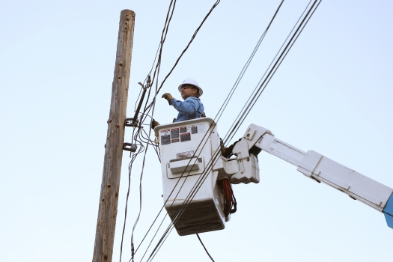
Figure 3: PG&E worker repairing a downed power line
Public Perceptions on PG&E as a For-Profit Corporation
The UC Berkeley Institute of Governmental Studies conducted a poll for the Los Angeles Times in 2019, shortly after PG&E filed for bankruptcy. The poll was conducted between November 21 and 26, covering a total of 3,482 California voters. When asking voters what the best path forward for PG&E is, results from the Berkeley poll indicated that:

- 35 percent of voters said they would allow PG&E to remain an investor-owned utility.
- 37 percent of voters supported government-run models.
- Roughly 28 percent offered no opinion at all.

Additional results found that:
- About 14 percent of likely voters “endorsed splitting PG&E’s gas and electricity divisions into two separate companies that would remain investor-owned and regulated by the California Public Utilities Commission.”
- Roughly 17 percent said that “PG&E should be converted into a state-run agency, with government officials responsible for fixing its problems in the future.”
- Twenty percent want to “divide the company into smaller, non-profit city and county cooperatives.”
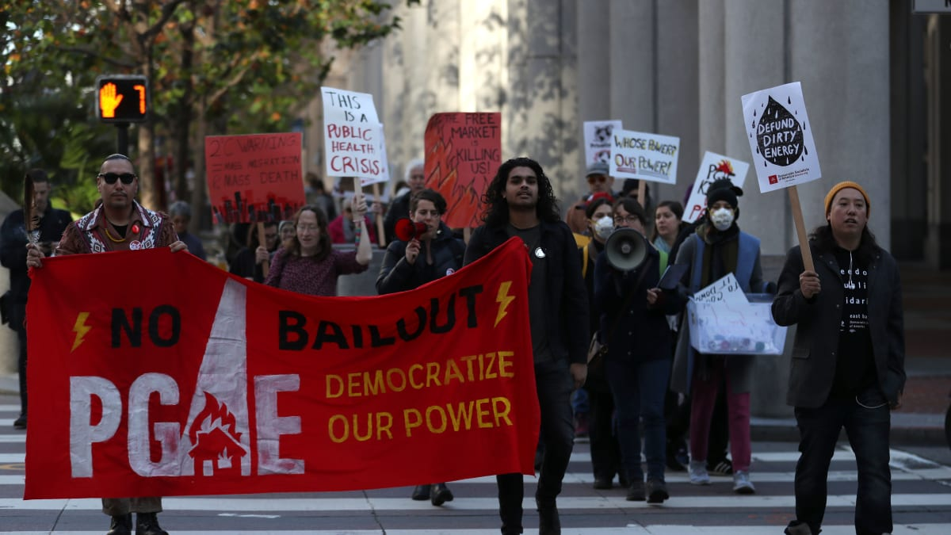
Figure 4: Protestors in favour of privatizing PG&E
Pacific Gas & Electric’s investor-owned-utility model has stirred controversy, influencing the growing movement among Californians to seek alternative models to which the utility is owned and operated from. Sentiments range from the current model prioritizing profits over ensuring their equipment upholds safety standards, victims of wildfires are adequately compensated, and the cost of utilities are manageable per household.
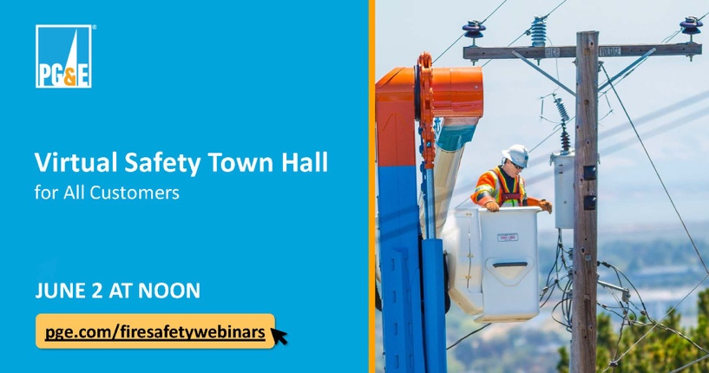
In 2020, PG&E “agreed to forgo paying shareholder dividends for about three years, accept more stringent state oversight and replace certain existing financing with $7.5 billion of securitization financing to reduce the rate impact on customers and to accelerate payments to wildfire victims.” However, the detrimental effects already felt by those victim to PG&E activity has resulted in growing antipathy towards investor-owned utilities and Wall Street, as they are accountable only to its shareholders.
The consideration of PG&E’s growing dissatisfaction rates, alongside the significant number of Californian voters either opting to alter its current investor-owned model or turn PG&E into a state-owned utility, give reason to considerably reconsider the company’s current model of operations as its long-term viability depends on it.
Figure 5: Advertisement for a PG&E Virtual Safety Town Hall in Sonoma

Implications on Marginalized Communities
Both historical and present-day systems of inequity have left people of color exposed to far greater environmental health hazards – the utility-related wildfires in California are no exception. The racial wealth gap in the United States serves as a considerable obstacle to access the necessary financial resources to build resiliency in the face of a wildfire.
In a study conducted in 2018, it was found that racialized communities – specifically Black, Hispanic, and Indigenous communities – are about 50 percent more vulnerable to wildfires compared to others. The three racial groups are overrepresented among the 12 million socially vulnerable Americans for whom a wildfire event could be devastating. With specific regards to Indigenous populations, forced relocation onto federal reserves – mostly rural, remote areas that are more prone to wildfires – paired with greater levels of vulnerability due to socioeconomic barriers magnifies the challenges of recovery post-fire.
Further, although measures have been taken by PG&E to mitigate the risk of wildfires, the new mitigation strategies continue to impose disproportionate risk on vulnerable communities. The company’s Public Safety Power Shut-Offs, otherwise known as PSPS events, involves shutting off power in high fire-risk areas during dry, windy weather. In 2019, the PSPS events left almost a million customers in the dark for seven days. Power shutoffs have immense impacts on California’s vulnerable communities. Those that do not have the means to relocate or support an external power generator exhibit high levels of job, food, and health insecurity during sustained periods without power, thereby exacerbating their positions of vulnerability.

Mitigations
A 2015 report published in the Frontiers in Psychology journal on Understanding the human dimensions of a sustainable energy transition lists several factors which contribute to the acceptability of energy policies and energy systems. Said factors prove relevant as the widespread disapproval of PG&E activity and its investor-owned model affect the way in which policies that influence their energy provision and PG&E services are accepted by the public.
In alignment with the 2015 report, PG&E is first advised to employ a more collaborative approach with local communities in California and surrounding regions prior to embarking on new ventures. The engagement process should be twofold as PG&E is advised to first provide complete transparency regarding proposed developments, the associated risks to users, and subsequent mitigation strategies. Secondly, it is recommended that PG&E consistently collects related feedback or outstanding concerns from community members to whom the developments would affect. Pacific Gas and Electric is encouraged to institute an engagement process like the one stated above regarding existing services and utility developments as well. This process allows for community members to feel actively involved and valued by PG&E, increasing the likelihood to which energy policies favoring PG&E and energy systems developed by the company are initially accepted.
It remains integral that PG&E organizes engagement processes around company activity that can be altered to reflect community needs, rather than PG&E facilitate “fake” engagement as it results in company distrust and ultimately, less public support.
Secondly, PG&E is advised to act beyond the initial community-engagement process, and gradually work towards instituting amendments to their developments that reflect considerations expressed from users and local community members. A displayed commitment to this conscious process prompts public approval of energy policies favouring PG&E and energy systems developed by the company as such changes reflect their concerns and values. Moreover, acting on concerns expressed by communities particularly vulnerable to PG&E activity promotes company-credibility as at-risk communities are not left to bear the brunt of the sustainable energy transition.
The shift to integrating local community concerns into the blueprints of PG&E developments can especially aid in transforming the growing sentiment of distaste for investor-owned-utility models as well as Wall Street. While this shift must be accompanied by adjustments to the profit margins of PG&E investors, such transitions exhibit PG&E attempting to prioritize the lives and well-being of consumers over profits. With consistent demonstration of PG&E attempting to consistently re-invest in their utility service, unfavorable attitudes towards investor-owned utilities and Wall Street have the potential to subside.
Moreover, PG&E’s renewed effort to rehabilitate their community relations can enable populations to wholly recognize the benefits of the utility’s energy storage component. Regarding economic benefits, energy storage technologies have the potential to offset various costs pertaining to the “generation, transmission, and distribution infrastructure.” An effort on behalf of PG&E to reduce costs to consumers considering the saved operation costs can aid in enhancing PG&E’s perception alongside the role ES technologies can play in producing economic benefits. Nevertheless, ES technologies “could also significantly reduce the requirement for investment in low-carbon generation capacity while achieving the established carbon intensity targets.” Evidently, ES technologies are relevant in contributing to environmental conservation efforts, providing the potential for PG&E to stand at the forefront of this transition. Finally, ES technologies produce less carbon dioxide emissions due to the increased amount of clean energy emitted. Once PG&E make amendments to ensure the greater safety of their equipment, the long-term environmental benefits produced from the storage facility will gauge greater favorability- of the company, and energy storage overall.
Conclusively, the growing social dissatisfaction with PG&E amidst California and surrounding regions requires immediate implementation of the mitigation strategies above. As noted, this consists of employing a collaborative approach by engaging with local communities, alongside gradually instituting such concerns in future developments to the utility, to ultimately gain greater credibility and favorability. Additional requirements to be made include following through on promises made to not create further dissatisfaction among the public, alongside developing and presenting a plan to adequately compensate wildfire victims as their lack of payment has generated media attention, placing PG&E in an antagonistic light.
PG&E’s 2021 Fire Mitigation Plan and their Better Together Resilient Communities Grant Program include several measures aimed at mitigating both the risk of wildfires as well as the residual long-term implications of the fire. The two strategies focus on infrastructure development, the implementation of new preventative technologies as well as investments into community resilience projects. However, the mitigation strategies both fail to explicitly address the needs of disadvantaged and vulnerable communities.
Permanent and consistent means of financing local, community-level recovery programs should be implemented and sustained to support populations vulnerable to wildfires. While wildfires significantly impact the land and its surrounding ecosystem, the social and economic implications on racialized minorities – and the ripple effects on the community – are critically important to address as well. It is proposed that PG&E expand its Resilient Communities Program to include a comprehensive support structure that provides families and communities, on a needs basis, with the resources necessary to sustain themselves during a power shutoff or to re-stabilize post-fire. This involves planning and outreach efforts to enhance the resilience of fire-prone communities of color.

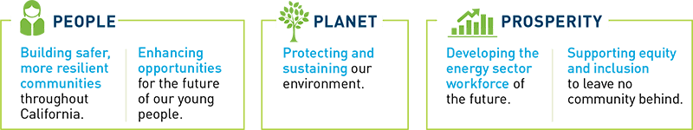
Figure 6: PG&E charitable contribution objectives

Policy Risk
Background
Governments play an influential role in shaping the clean energy sector by creating policies that ensure that sustainability is a priority. Energy storage systems are becoming increasingly popular in the clean energy sector; therefore, the US is working to create policies that reflect the need for sustainable energy storage practices. There has been a significant increase in energy storage-related measures under consideration by state legislatures, going from 88 energy storage-related measures in 2018 to 260 in 2020. In February 2018, the Federal Energy Regulatory Commission (FERC) unanimously created a federal order that mandated the evaluation of the tariffs for energy storage systems which can help decrease the various barriers in place to securing energy storage systems. Along with additional federal investment towards energy storage innovation, federally, the government has begun to recognize the benefits associated with energy storage systems.
This section will identify three major risks associated with energy storage which include, the lack of state-made energy storage policies, uncertainty regarding the new technology and the lack of incentive to incorporate energy storage systems within homes. To mitigate these challenges, this section will refer to the strategies utilized by the Government of California, a major state paving the way in the policy realm of energy storage.
Figure 7: Governor Gavin Newson of California

Risks
Risk #1: The lack of policies in place in the states to prioritize energy storage
Energy storage systems enable the reduction of greenhouse gas emissions by creating more efficient uses of energy. By integrating energy storage systems into the energy market, not only are there positive environmental impacts but also improved reliability during power outages, along with reducing consumer spending in the long run. As energy storage actively plays an increasingly influential role in the energy sector, instating regulatory policies at the state level will enable tangible growth in the energy storage market. Despite the major benefits associated with energy storage systems, currently, at the state level, there is a lack of energy storage policies in place. In June 2021, only eight out of the fifty states had energy storage policies in place. This poses a major risk to the transition towards renewable energy.

Risk #2: Uncertainty regarding new technology and potential for high upfront costs
The utility grid is continually evolving to reflect the most cost-effective and innovative technologies. Over the past decade, the overall costs of energy storage systems have significantly decreased, especially given the FERC’s order to reduce barriers to energy storage policies. Recognizing the unique nature of energy storage systems, a major risk associated with energy storage policies is the overall inexperience with energy storage systems, resulting in a lack of understanding of the various associated costs. Only 30-40 percent of the costs are “hard costs,” which is the technology, whereas the majority of the costs are engineering, auxiliary technologies, integration known as “soft costs.” Despite the decreased hard costs associated with the innovative technology, there is a trade-off with the higher costs of electricity and higher upfront capital costs for energy storage systems.

Risk #3: The lack of incentive to use energy storage
As a result of California utilities often being shut off to avoid the creation of wildfires, many citizens lose their power for hours and sometimes days. For those in low-income communities and the medically vulnerable who rely on electrical medical assistance devices, this poses a major risk. Energy storage systems can be utilized in times of power outages and can help reduce the disproportionate impacts of power outages. Currently, in many states, market rules prohibit the use of and monetization of the value of energy storage systems which adversely impacts the use of energy storage systems. Based on the cost-benefit analysis done by the Government of Massachusetts, New York, and Nevada, it was determined that the energy storage market can highly benefit customers and the overall electric system.

Mitigations
Mitigation strategy for Risk #1
To mitigate the issue of the lack of state policies in place regarding energy storage, this section is informed by the creation of California’s energy storage policies. State governments should work alongside the Energy Storage Association (ESA) to help create policies best suited for their state. The ESA works to develop cost-benefit analysis looking at the various options for energy storage specifically relating to the state along with creating deployment strategies, incentive programs and business models. Additionally, states should refer to the Government of California’s policies in place as precedent to inform their creation of policies. California, a major state paving the way in the policy realm of energy storage, was the first state to create an energy storage target using a major bill known as Bill 2514, approved in September 2010. As a call to action, this bill began changing the energy sector by calling upon the CPUC to expand the use of energy storage systems on the electricity grid. This requires the governing boards of all public-owned utilities to set energy storage goals to be reviewed every three years. For the three major investor-owned utilities of California, including PG&E, this bill set the target of 1,325 MW of energy storage by 2020. By 2016, California had extended its energy storage systems goals by passing four additional bills. Bill 2868 was passed sets new goals for 2024 for the three of California’s investor-owned electric utilities. The various other policies introduced in 2016 include AB 1637, AB 2861, and AB33, which all work to expand the use of energy storage systems. Therefore, to mitigate the risk of a lack of policies in place in states, by utilizing the insights of the ESA and using the experiences of California, governments can create policies that reflect their state’s context regarding energy storage systems.
Figure 8: CESA Market Development Forum Advertisement
The government works alongside PG&E on the federal, state and local levels concerning energy storage policies. As a California-based company, the Sustainability and Governance Committee of the PG&E Corporation Board of Directors completes research and advisory reports to assist and inform the Board of Public Policy and how it relates to the interests of the company, consumers and stakeholders. PG&E’s Public Policy Committee of the Board looks specifically at both federal and state lobbying efforts to create policies that reflect the concerns of the company and the overall population. Ultimately, PG&E have a variety of measures in place to address changes in energy storage policies.
Mitigation strategy for Risk #2
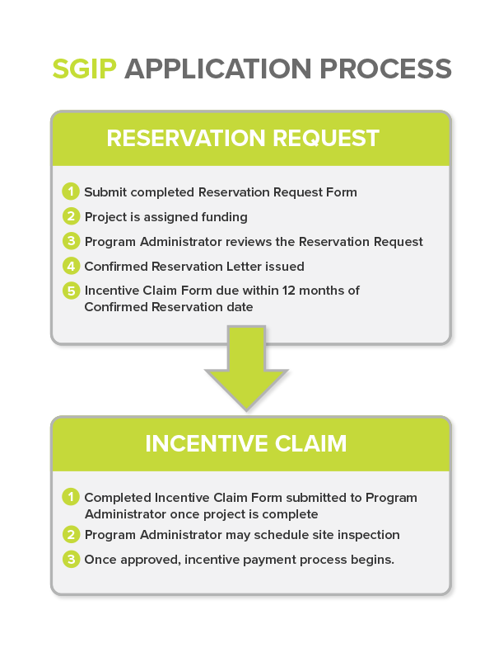
Despite the recognition that there is a high upfront cost, the energy storage global market is expected to be worth over $100 billion by 2024. Firstly, there are a variety of different organizations continually working to decrease the costs of energy storage systems such as the Department of Energy that have partnered with other 26 academic institutions and 43 industry partners. Additionally, costs of energy storage systems can be reduced by utilizing a variety of more cost-effective materials such as low-cost membranes for flow batteries along with advanced cell materials. Two major cost-effective battery options include lithium-ion batteries and lithium-sulfur batteries. In 2018, PG&E was approved by the CPUCin creating four new energy storage projects that are more cost-effective which utilize lithium-ion batteries.
The Government of California is continually working to find more cost-effective energy storage strategies. In 2014, the CPUC worked alongside various stakeholders and experts to create the California Energy Storage Roadmap, which detailed the variety of revenue opportunities, cost reduction strategies associated with integration along with providing clarity regarding goals of energy storage projects. Additionally, in 2017, California passed Bill 801, which worked alongside the Los Angeles City Council to find the most cost-effective and reliable options to address the electricity disparities in their electrical system. Ultimately, states should follow the lead of California by analyzing their cost-reduction strategies to be translated to reflect the needs of their communities.

Mitigation strategy for Risk #3
To mitigate the risk of lack of incentive, states should follow the Government of California policy initiative known as the Self-Generation Incentive Program (SGIP), which acted as a financial incentive to encourage energy storage projects between 2017-2021. This policy program is known as one of the first “equity-focused” incentive programs that provide individuals with a financial incentive to install energy storage systems in their homes. Initially, the program was not entirely successful due to the lower financial incentives, however, the program has increased the “funding for education and community engagement, and a more streamlined approach.” Some recommendations SGIP is incorporating include working to identify the various barriers for marginalized and low-income citizens’ use of energy storage systems, in addition to creating outreach programs and stakeholder engagement strategies. For example, PG&E not only uses SGIP, but also provides clear instructions and benefits about how home-owners can become eligible for SGIP. Therefore, to incentivize the use of energy storage systems, governments should utilize SGIP as a framework to guide the creation of incentive programs in their home states.
Figure 9: SGIP Program Flow-Chart

Figures

Figure 1. Liedtke, Michael, and Olga R. Rodriguez. “PG&E to Plead Guilty to Lethal Crimes in 2018 California Wildfires.” CTVNews, March 24, 2020. https://www.ctvnews.ca/world/pg-e-to-plead-guilty-to-lethal-crimes-in-2018-california-wildfires-1.4865461?cache=gszlebujvvuylyge%3FclipId%3D104062.
Figure 2. Luna, Taryn. “California Utilities Agree to Pay $10.5 Billion into New Wildfire Fund.” Los Angeles Times. Los Angeles Times, July 25, 2019. https://www.latimes.com/california/story/2019-07-25/california-utilities-agree-to-pay-10-5-billion-into-new-wildfire-fund. https://www.macleans.ca/politics/election-2019-this-is-what-the-house-of-commons-will-look-like/
Figure 3. Associated Press. “$166 Million in Fines Recommended for PG&E over Power Outages.” The Mercury News. The Mercury News, November 1, 2020. https://www.mercurynews.com/2020/11/01/166m-in-fines-recommended-for-pge-over-power-outages/.
Figure 4. ““Reclaim Our Power: Utility Justice Campaign.” Reclaim Our Power: Utility Justice Campaign | Local Clean Energy Alliance of the Bay Area. Accessed August 6, 2022. http://localcleanenergy.org/UtilityJustice.

Figure 5. “PG&E Virtual Safety Town Hall.” City of Sonoma, May 27, 2021. https://www.sonomacity.org/pge-virtual-safety-town-hall-june-2nd-12-pm/.
Figure 6. “Better Together Giving Program.” Giving Locally. Accessed August 6, 2022. https://www.pge.com/en_US/residential/in-your-community/pge-gives-back/giving-locally/giving-locally.page.
Figure 7. Axelrod, Tal. “California Gov: State Could Take over PG&E in Wake of Bankruptcy Crisis.” The Hill. The Hill, December 18, 2019. https://thehill.com/homenews/state-watch/468683-california-governor-says-if-pge-doesnt-get-itself-out-of-bankruptcy-the/.

Figure 8. California Energy Storage Alliance. Accessed August 6, 2022. https://www.storagealliance.org/.
Figure 9. “Self-Generation Incentive Program (SGIP).” Blogs | Infinity Energy Inc., July 10, 2020. https://infinityenergy.com/blog/self-generation-incentive-program-sgip.

Citations

Jim Doyle, “Utility Giant Grew from Gold Rush Roots”, SFGate, April 7, 2001.
Pacific Gas and Electric Company: Company Profile, Last updated: 2022.
Ibid.
Peter Eavis, James Glanz, Ivan Penn, “How PG&E Ignored Fire Risks in Favor of Profits”, New York Times, March 18, 2021.
“PG&E Is Charged With Manslaughter In A California Wildfire That Killed 4”, NPR, September 4, 2021.
Ivan Penn, “PG&E Equipment is Blamed for Starting the Dixie Fire in Northern California”, New York Times, January 4, 2022.
Emma Newburger, “Californa Finds PG&E Equipment Responsible for Massive Dixie Fire”, CNBC, January 5, 2022.
The American Clean Power Association. January 5th, 2022. https://energystorage.org/why-energy-storage/
Nicholas Iovino, “PG&E files for bankruptcy, citing wildfire liabilities,” Courthouse News Service, January 14, 2019
Sharon Bernstein, “PG&E files for bankruptcy as California wildfire liabilities loom,” Reuters, January 29, 2019.
Bhargav Acharya, “Bankrupt PG&E reaches $13.5 billion settlement with California wildfire victims,” Reuters, December 6, 2019.
Fire Victim Trust, “Claimant information guide,” January 10, 2021, https://www.firevictimtrust.com/Docs/FAQs.pdf.
Fitch Ratings: Credit Ratings & Analysis for Financial Markets, accessed March 24, 2022, https://www.fitchratings.com/research/corporate-finance/fitch-rates-pacific-gas-electric-co-fmbs-bbb-rr1-08-03-2021#:~:text=PG%26E%27s%20Issuer%20Default%20Rating%20is.
“Rating Definitions,” Fitch Ratings, accessed March 24, 2022, https://www.fitchratings.com/products/rating-definitions#about-rating-definitions.
PG&E Corporation, “2020 Third Quarter Earnings.”
California State Association of Counties, “Inverse condemnation and utility liability,” http://www.counties.org/sites/main/files/fileattachments/csac_issue_brief_inverse_condemnation_7-25-18.pdf.
Ibid.
Christopher Helman, “How the future of California’s power grid hangs on the constitutionality of ‘inverse condemnation,” Forbes Magazine, October 30, 2019.
Danko Meredith Trial Lawyers, “inverse condemnation and PG&E wildfires,” August 22, 2021, https://www.dankolaw.com/inverse-condemnation-and-pge-wildfires/.
Jeff St. John, “Post-bankruptcy PG&E faces lawsuit for its role in causing the 2019 Kincade wildfire,” Green Tech Media, July 17, 2020.
Ibid.
Mallika Kallingal and Stella Chan, “Pacific Gas & Electric fined $125 million for 2019 Kincade fire,” CNN, December 3, 2021.
Sarah Moon and Stella Chan, “PG&E charged with manslaughter over 2020 Zogg Fire, which killed 4 people,” CNN, September 24, 2021.
Ibid.
Scott Rodd, “PG&E Could Be the First Utility to Access California's Wildfire Liability Fund after Starting Dixie Fire,” CapRadio, accessed March 24, 2022, https://www.capradio.org/articles/2022/01/06/pge-could-be-the-first-utility-to-access-californias-wildfire-liability-fund-after-starting-dixie-fire/.
Fitch Ratings: Credit Ratings & Analysis for Financial Markets, accessed March 24, 2022, https://www.fitchratings.com/research/corporate-finance/fitch-rates-pacific-gas-electric-co-fmbs-bbb-rr1-08-03-2021#:~:text=PG%26E%27s%20Issuer%20Default%20Rating%20is.
Christopher Helman, “How the future of California’s power grid hangs on the constitutionality of ‘inverse condemnation,” Forbes Magazine, October 30, 2019.
Ibid.
PG&E Corporation, “Risk Management - PG&E Corporate Responsibility and Sustainability Report 2018.”
Lagos, Marisa. 2019. "Californians Are Angry At PG&E Over Blackouts — And They’re Not Sparing Newsom". KQED. https://www.kqed.org/news/11782081/poll-shows-anger-at-pge-gavin-newsom-over-blackouts.
"Home - Change Research". 2022. Change Research. https://changeresearch.com/.
Lagos, Marisa. 2019. "Californians Are Angry At PG&E Over Blackouts — And They’re Not Sparing Newsom". KQED.
Ibid.
Luna, Taryn. 2019. "Californians Want To End PG&E's Operations As They Exist Now, New Poll Says". Los Angeles Times. https://www.latimes.com/california/story/2019-12-10/poll-californians-pge-operations.
Brinklow, Adam. 2019. "90 Percent Of Bay Area Residents Wants To Get Rid Of PG&E, Says Poll". Curbed SF. https://sf.curbed.com/2019/12/10/21005182/uc-berkeley-poll-pge-fires-blackout-breakup.
Luna, Taryn. 2019. "Californians Want To End PG&E's Operations As They Exist Now, New Poll Says". Los Angeles Times.
Ibid.
Ibid.
Ibid
Ibid.
Ibid.
Lowrey, Dan. 2020. “PG&E Accepts Dividend Restrictions In Restructuring Deal With Governor”. S&P Global.https://www.spglobal.com/marketintelligence/en/news-insights/research/pge-accepts-dividend-restrictions-in-restructuring-deal-with-governor
Ma, Michelle. 2018. “Racial, ethnic minorities face greater vulnerability to wildfires.” UW News. https://www.washington.edu/news/2018/11/02/racial-ethnic-minorities-face-greater-vulnerability-to-wildfires/
Ibid.
Thurton, David. 2021. “Climate change threatens remote and rural communities nationwide: report.” CBC News. https://www.cbc.ca/news/politics/climate-change-heat-wave-lytton-1.6088813
Penn, Ivan. 2022. “PG&E agrees to pay $55 million in penalties and costs over two wildfires.” The New York Times. https://www.nytimes.com/2022/04/11/business/energy-environment/pge-wildfire-settlement.html
Penn, Ivan, Peter Eavis and James Glanz. 2019. “How PG&E ignored fire risks in favour of profit.” The New York Times. https://www.nytimes.com/interactive/2019/03/18/business/pge-california-wildfires.html
Ibid.
Linda Steg, Goda Perlaviciute, Ellen van der Werff, “Understanding the human dimensions of a sustainable energy transition”. Frontiers in Psychology 6, no.805 (2015): 1
Steg, “Understanding the human,” 10.
Ibid.
Ibid.
Steg, “Understanding the human,” 9.
Steg, “Understanding the human,” 10.
G. Strbac et al., "Opportunities for Energy Storage: Assessing Whole-System Economic Benefits of Energy Storage in Future Electricity Systems". IEEE Power and Energy Magazine 15, no.5 (2017): 32.
Ibid.
Eric Hittinger and Rebecca E. Ciez, “Modeling Costs and Benefits of Energy Storage Systems”. Annual Review of Environment and Resources 45, (2020): 460.
Ilya Chernyakhovskiy et al., “USAID Energy Storage Decision Guide for Policy Makers,” National Renewable Energy Laboratory, 2021, https://www.nrel.gov/docs/fy21osti/78815.pdf.
Laura Shields, “The Growing Role of Energy Storage in Clean Energy Policy,” National Conference of State Legislatures, 2020, https://www.ncsl.org/research/energy/the-growing-role-of-energy-storage-in-clean-energy-policy.aspx.
Alexandra Zablocki, “Fact Sheet: Energy Storage (2019),” Environmental and Energy Study Institute, 2019, https://www.eesi.org/papers/view/energy-storage-2019#4.
Energy Storage Association, “Benefits of Energy Storage: Energy Storage Association,” Energy Storage Association, September 24, 2020, https://energystorage.org/why-energy-storage/benefits/.
Sonal Patel, “Connecticut Becomes Eighth State to Adopt Energy Storage Targets,” POWER Magazine, June 24, 2021, https://www.powermag.com/connecticut-becomes-eighth-state-to-adopt-energy-storage-targets/.
Department of Energy, “Solving Challenges in Energy Storage,” Department of Energy, 2019, https://www.energy.gov/sites/default/files/2019/07/f64/2018-OTT-Energy-Storage-Spotlight.pdf. ; Ilya Chernyakhovskiy et al., “USAID Energy Storage Decision Guide For Policy Makers,” National Renewable Energy Laboratory, 2021, https://www.nrel.gov/docs/fy21osti/78815.pdf.
Energsoft - Predictive Battery Analytics Software, “Energy Storage Problems - Battery Analytics Software,” Energsoft - Predictive Battery Analytics Software, 2019, https://energsoft.com/blog/f/energy-storage-problems.
Maria Blais Costello, “Preventative Shutoffs Are Resulting in a Medical Crisis: Resilient Power Can Help,” Clean Energy Group, October 29, 2019, https://www.cleanegroup.org/preventative-shutoffs-are-resulting-in-a-medical-crisis-resilient-power-can-help/.
Ibid.
Energy Storage Association, “Energy Storage Incentive Programs,” Energy Storage Association, 2019, https://energystorage.org/wp/wp-content/uploads/2019/09/Incentive-Report_v7.pdf.
Ibid.
Energy Storage Association, “Policies and Issues: States,” Energy Storage Association, December 31, 2021, https://energystorage.org/policies-issues/states/.
Calmac, “California's Assembly Bill 2514 and the Grid Storage Revolution,” Energy storage articles, 2016, http://www.calmac.com/energy-storage-articles?category=4229.
Ibid.
California Energy Commission, “Energy Storage Targets - Publicly Owned Utilities - AB 2514,” California Energy Commission (California Energy Commission, 2022), https://www.energy.ca.gov/data-reports/reports/energy-storage-targets-publicly-owned-utilities.
Peter Maloney, “California Looks to next Steps as Utilities near Energy Storage Targets,” Utility Dive, June 12, 2018, https://www.utilitydive.com/news/california-looks-to-next-steps-as-utilities-near-energy-storage-targets/525441/.
Peter Maloney, “California PUC Finalizes New 500 MW BTM Battery Storage Mandate,” Utility Dive, May 4, 2017, https://www.utilitydive.com/news/california-puc-finalizes-new-500-mw-btm-battery-storage-mandate/441901/.
Robert Walton, “Facing Stricter Climate Goals, California Passes 4 Bills to Boost Energy Storage,” Utility Dive, September 2, 2016, https://www.utilitydive.com/news/facing-stricter-climate-goals-california-passes-4-bills-to-boost-energy-st/425671/.
PG&E, “Political Engagement,” PG&E Political Engagement, 2022, https://www.pgecorp.com/corp/about-us/corporate-governance/corporation-policies/political-engagement.page.
PG&E, “Political Engagement.”
PG&E, “Advocacy and Lobbying Policies and Procedures,” PG&E Advocacy and Lobbying Policies, 2022, https://www.pgecorp.com/corp/about-us/corporate-governance/corporation-policies/political-engagement/advocacy-lobbying.page.
Ibid.
Chernyakhovskiy et al., “USAID Energy Storage Decision Guide for Policy Makers,”
Ibid.
Ibid.
PG&E, “PG&E Proposes Four New Cost-Effective Energy Storage Projects to CPUC,” PG&E Corporation, 2018, https://investor.pgecorp.com/news-events/press-releases/press-release-details/2018/PGE-Proposes-Four-New-Cost-effective-Energy-Storage-Projects-to-CPUC/default.aspx.
California Energy Commission, “Energy Storage - Tracking Progress,” California Energy Commission2018, accessed January 31, 2022, https://www.energy.ca.gov/sites/default/files/2019-12/energy_storage_ada.pdf.
Seth Mullendore , “Energy Storage Is Failing to Reach Those Most in Need: Policy Can Help,” Renewable Energy World, July 7, 2021, https://www.renewableenergyworld.com/blog/energy-storage-is-failing-to-reach-those-most-in-need-policy-can-help/#gref.
Ibid.
Ibid.
PG&E, “Discover the Self-Generation Incentive Program for Non-Residential Customers,” PG&E Corporation, 2022, https://www.pge.com/en_US/small-medium-business/energy-alternatives/private-solar/understand-the-solar-process.page?WT.mc_id=Vanity_sgip. ; PG&E, “Battery Storage for Your Home,” PG&E Corporation, 2022, https://www.pge.com/en_US/residential/solar-and-vehicles/other-solar-options/battery-storage-for-residential-customers.page.

